Create Client ID and Client Secret

យើងបង្កើត client សម្រាប់អោយ Client ធ្វើការ Authenticate to the Google
The client can log in to their google account to get the JWT.

https://console.cloud.google.com/auth/clients?project=my-spring-test-app-489909

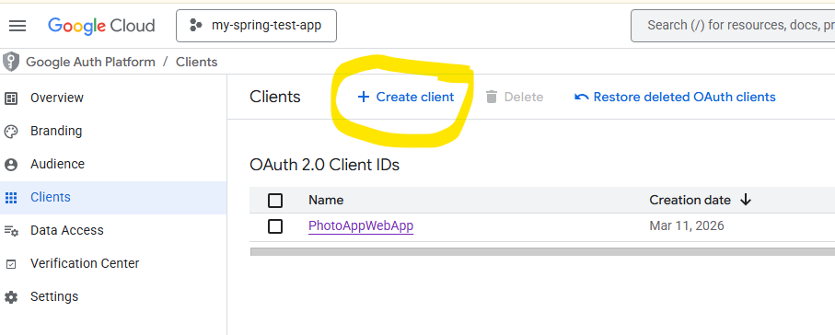

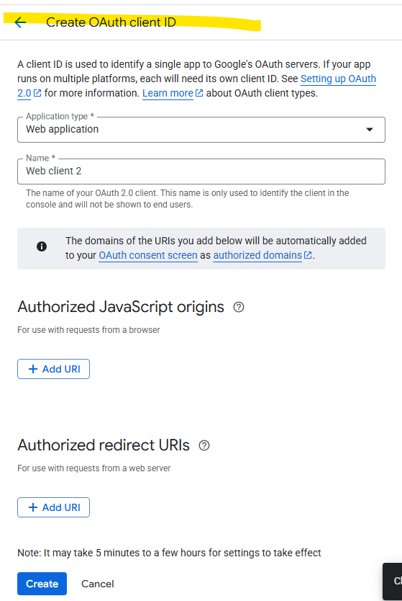

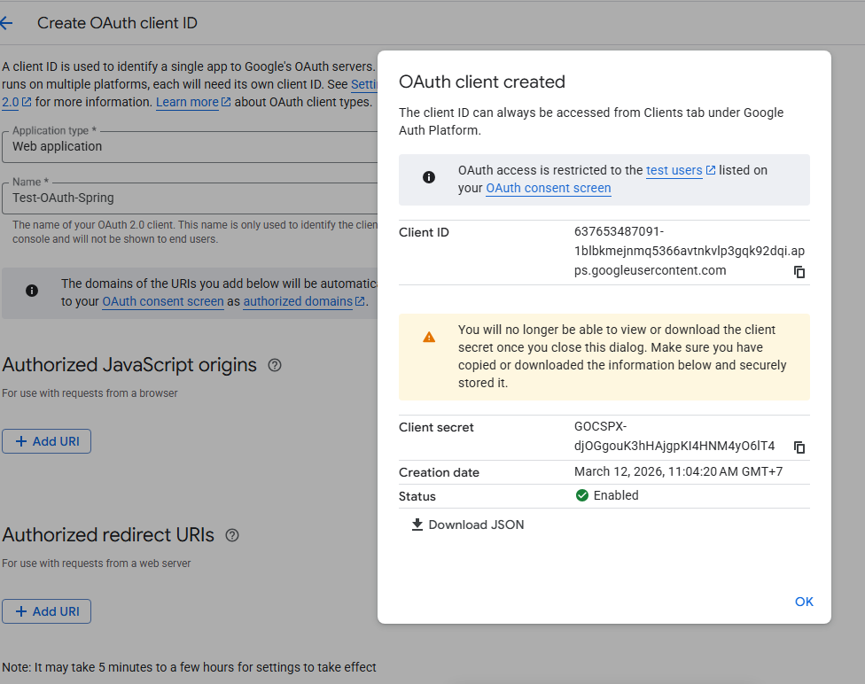

We can get the client id and client secret

